NAME | K9 or Feline

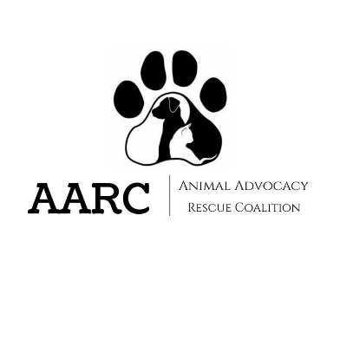

FOSTER CARE AGREEMENT
______ 1. For clear medical record tracking, I promise to refer to the animal(s) listed on the contract only by the names given by the AARC Staff and under no circumstances will rename the animal(s).
______2. I do not have any other animals in foster from another organization, or if I do, it has been approved by the Foster Care Coordinator prior to pick-up.
______3. I understand that the Animal Advocacy Rescue Coalition will provide ALL medical care while the animal or animals are in foster care, including vaccinations and spay/neuter. I promise not to provide any additional medications that have NOT been prescribed or approved by our medical team.
______4. I have been provided with AARC’s options for after hour emergency care. If I choose to take the animal(s) to a local veterinarian while they are in my care, I am solely responsible for the costs incurred. The Animal Advocacy Rescue Coalition will not reimburse vet costs that have not been approved by AARC Staff.
______ 5. I understand that the animal(s) I am fostering belong to the Animal Advocacy Rescue Coalition, and that the animal(s) I am fostering are temporarily in my care. I will, at no time, claim, assume or transfer ownership of the animal(s) I am fostering.
______ 6. I understand that I must return all animals in my care to the AARC at the scheduled time. I am responsible for contacting the shelter if extenuating circumstances are going to prevent the animal(s) from being returned at the appropriate time.
______ 7. I understand that if I decide to adopt an animal or have found an adopter for an animal I have in foster care, I must fill out an application, have it approved by the AARC staff, and pay the adoption fee.
______ 8. I understand the Animal Advocacy Rescue Coalition has not received an accurate assessment of known and unknown behaviors. By initialing and signing this document, I am releasing the Animal Advocacy Rescue Coalition and its agents from any liability associated with medical or property damages caused by the animal I am fostering.
______ 9. I assume responsibility for any accidental animal bites or other injuries to humans and other animals by the animal(s) in my care. Furthermore, I am releasing the Animal Advocacy Rescue Coalition and its agents from any liability, claims or suits filed by someone as a result of accidental injury caused by the animal(s) I am fostering.
______10. I agree to adhere to all state and local animal laws for the animal(s) I am fostering and animal(s) in my care.
______ 11. I understand that I must contact the AARC immediately if any animal in my care begins to have medical or behavioral issues.
______ 12. I understand that if I am contacted by the AARC, I am obligated to respond in a timely manner.
______ 13. I understand that I must provide adequate food, water, shelter, socialization and humane care to any and all animals while they are in my care.
______14. I understand that if I borrow equipment (heating pads, nebulizers, bottles, carriers, etc.) I will return it in a timely manner at the point of my foster animal’s return. If I fail to respect this, I will be responsible for the expenses incurred from our lost equipment.
__________________________________________________________________________________________________
FOR FOSTER-TO-ADOPT
____ 1. I will contact the Foster Care or Adoption Supervisor in the event that a medical issues arises with my foster animal, and will wait for an appointment to be set up before coming to the shelter (except for emergencies).
____ 2. I understand the foster-to-adopt period is 2 weeks, and if after 2 more weeks of failed attempted contact, the adoption staff has the right to finalize the adoption of the animal to me.
Current Foster’s Name: _____________________________________________________________________________
__________________________________________________________________________________________________

By signing below, I acknowledge that the information I provided to the AARC is correct to the best of my knowledge.

Date: __________ Printed name: ________________________________________
Signature: ___________________________________________
Phone Number: _______________________________________
Address: ____________________________________________
____________________________________________

Equipment borrowed:_______________________________________________________________________
AARC Staff releasing animals: _________________________________________________________________
AARC Staff signature: ________________________________________________________________________

